# **Activity:**

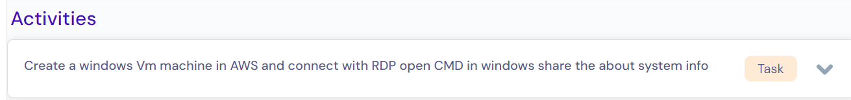

# Solution Method:

## Step1: Login to AWS with valid credentials.

## Step2: search “**EC2**” service in search box and click on “**EC2(Virtual servers in the Cloud)”**.

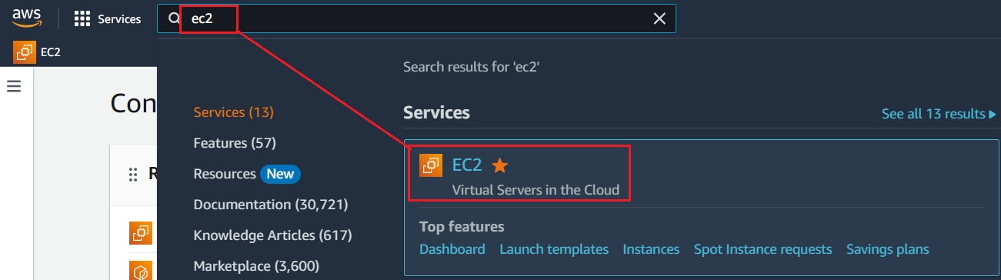

## Step3: EC2 Dashboard gets displayed and click on “**Launch instance**” as show below.

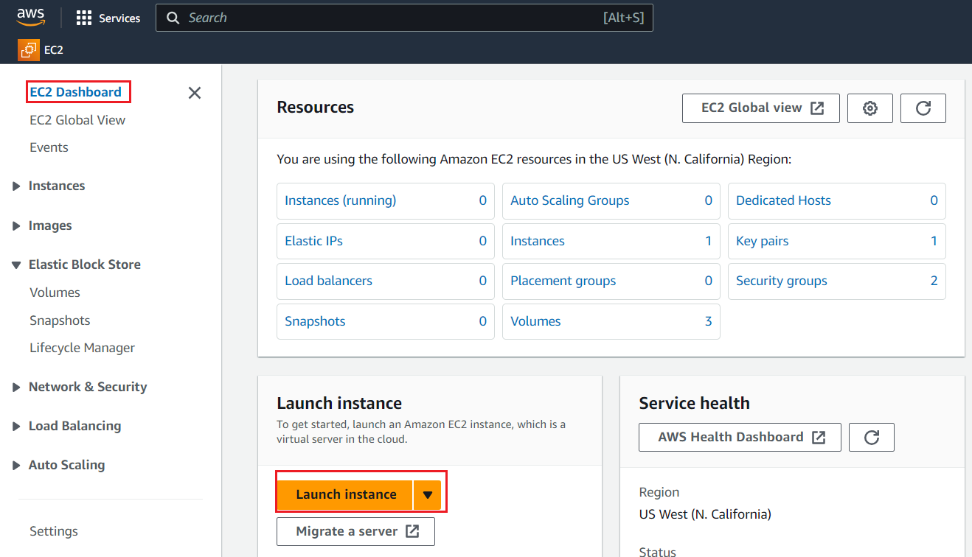

## Step4: follow the below picture to fill out all required details.

Name: **windows-test01** (it can be any name)

Application and OS Images (Amazon Machine Image): **Windows**

Instance type : **t2.micro** (as per need)

Key-pair**: As per need.**

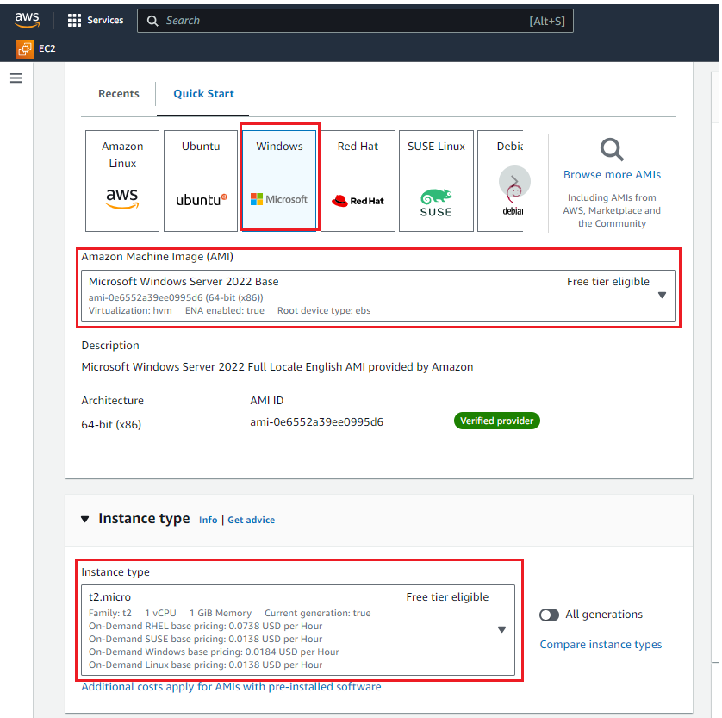

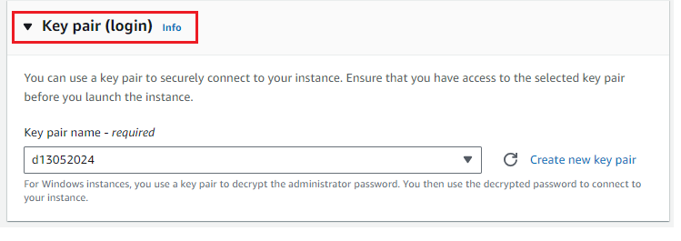

Choose network settings as per actual plan such as VPC, subnet, Auto-assign public IP = **Enable,** Firewall (security groups),

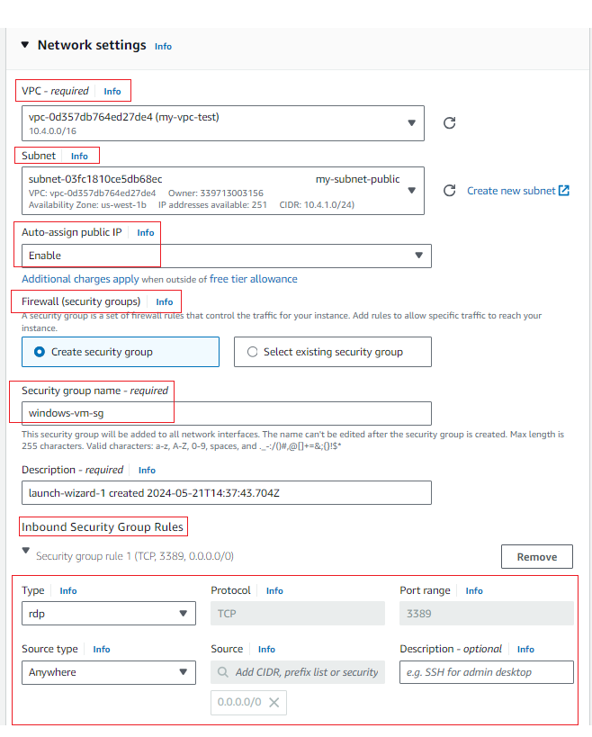

## Step5: Click on “**Launch instance**”

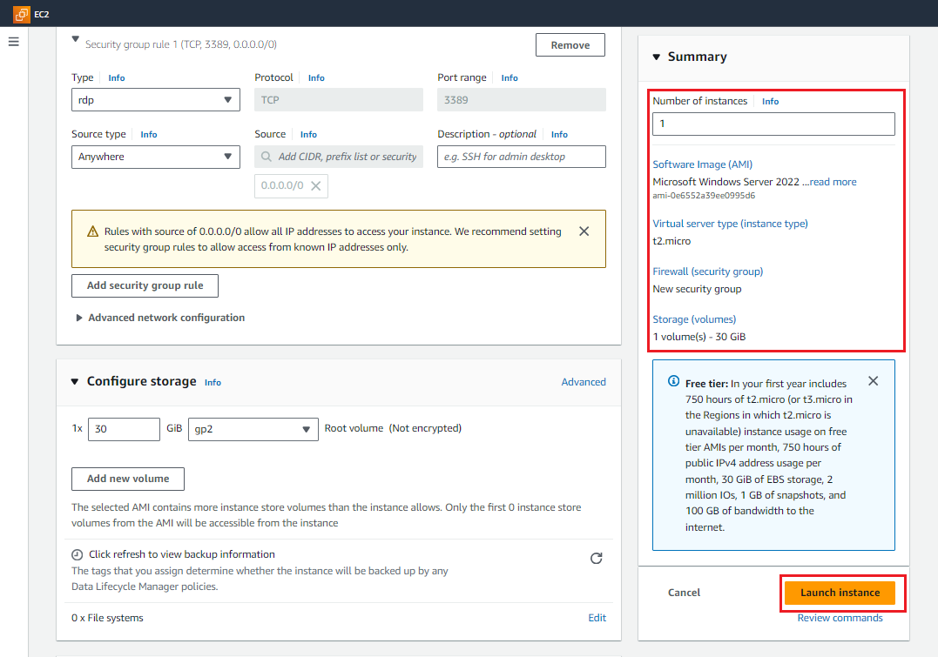

## Step6: If below Success message is displayed, then instance has been created successfully.

Click on **instance_id** as shown below.

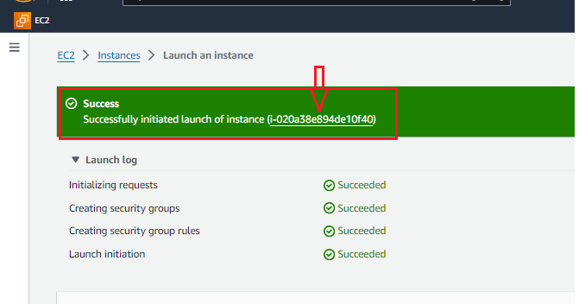

## Step7: instance has been created and make sure **instance state= Running** and **Status check = Passed**

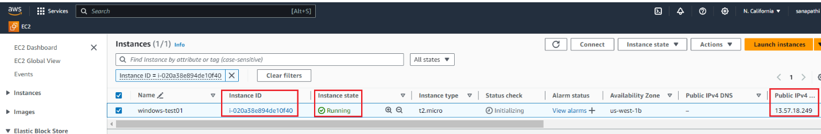

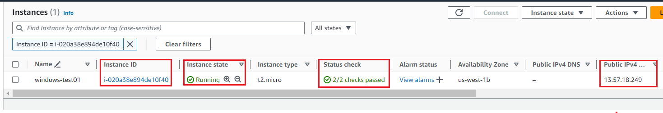

## Step8: select **instance** to view more details.

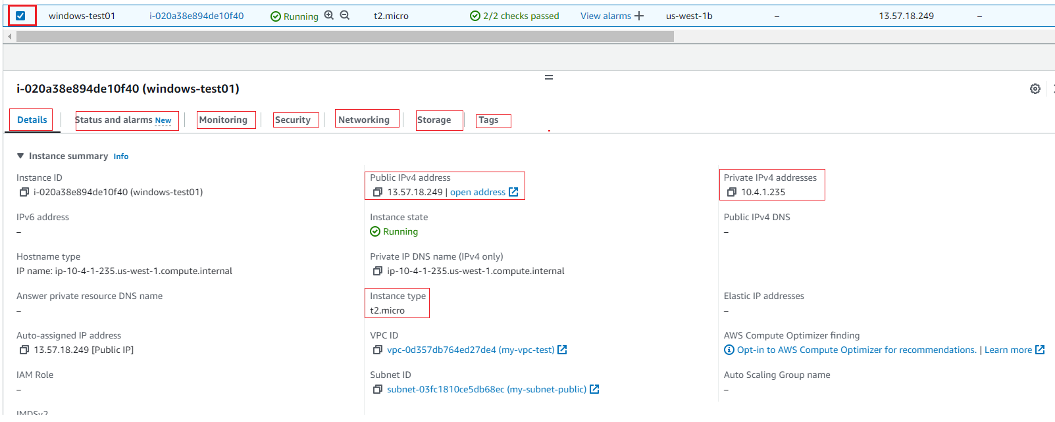

## Step9: select **instance** and click on “**Connect**”.

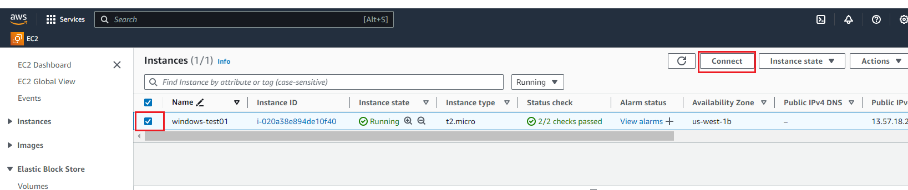

## Step9: select **“RDP client”** and click on “**Get password**”.

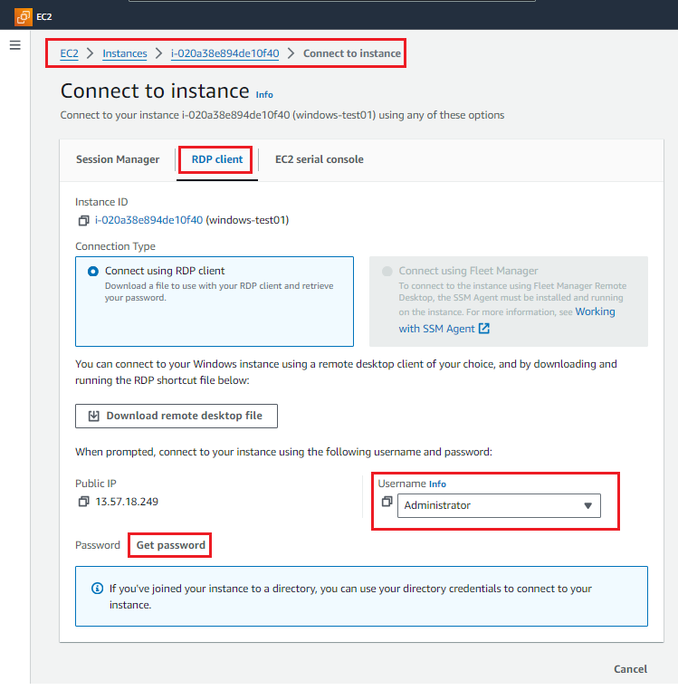

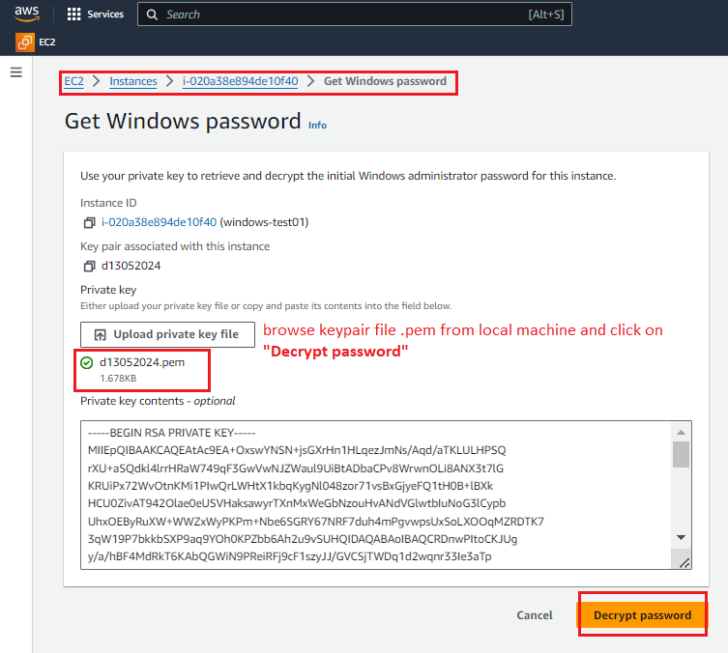

## Step10: Copy **password** as shown below and click on “**Download remote desktop file**” and **open it.**

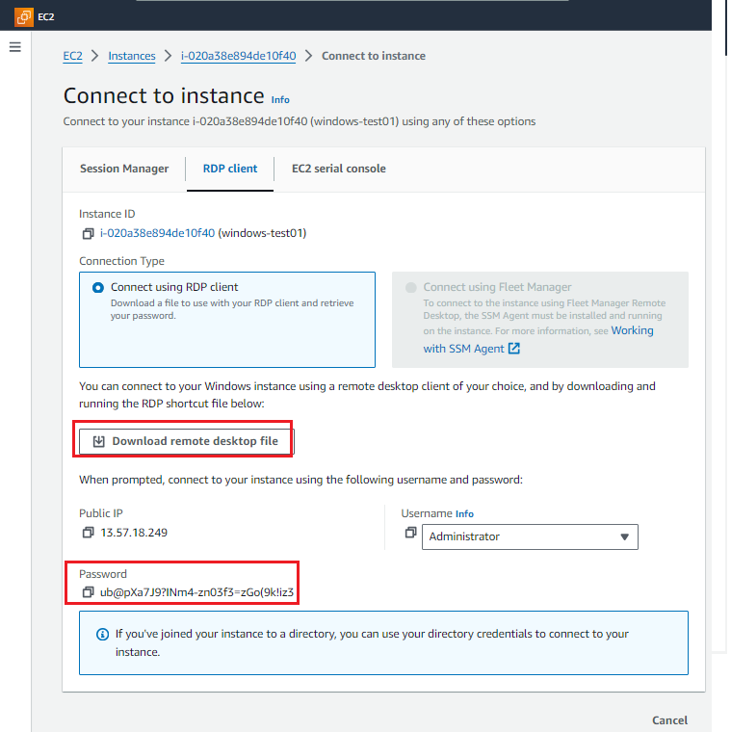

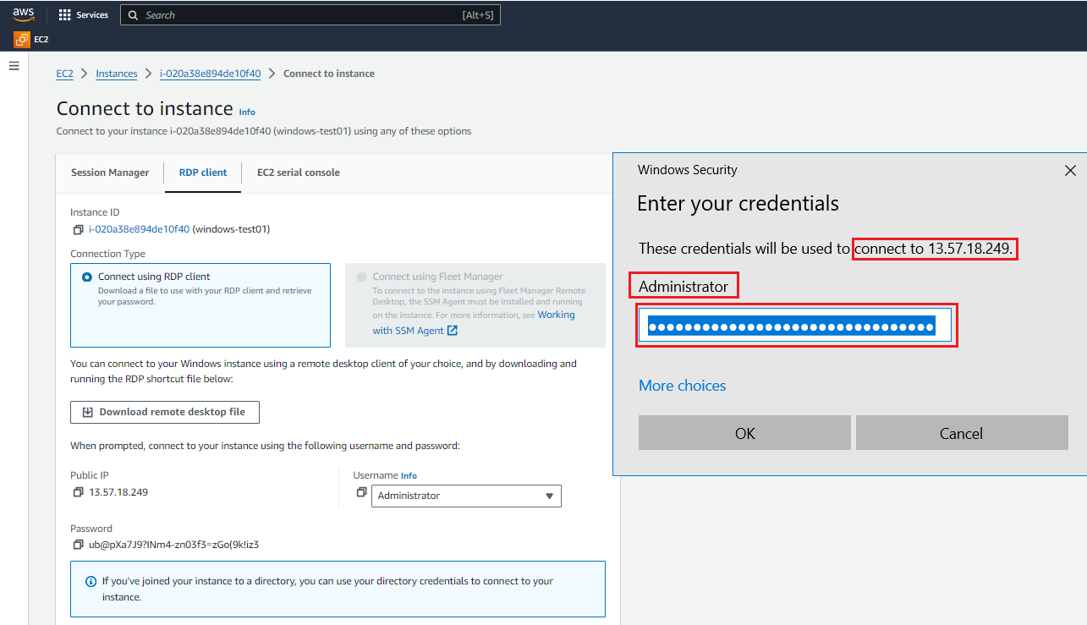

Click on **“Yes”**

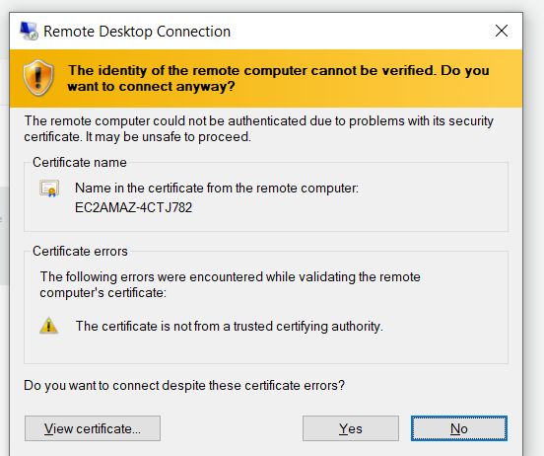

## Step11: connected to windows VM successfully.

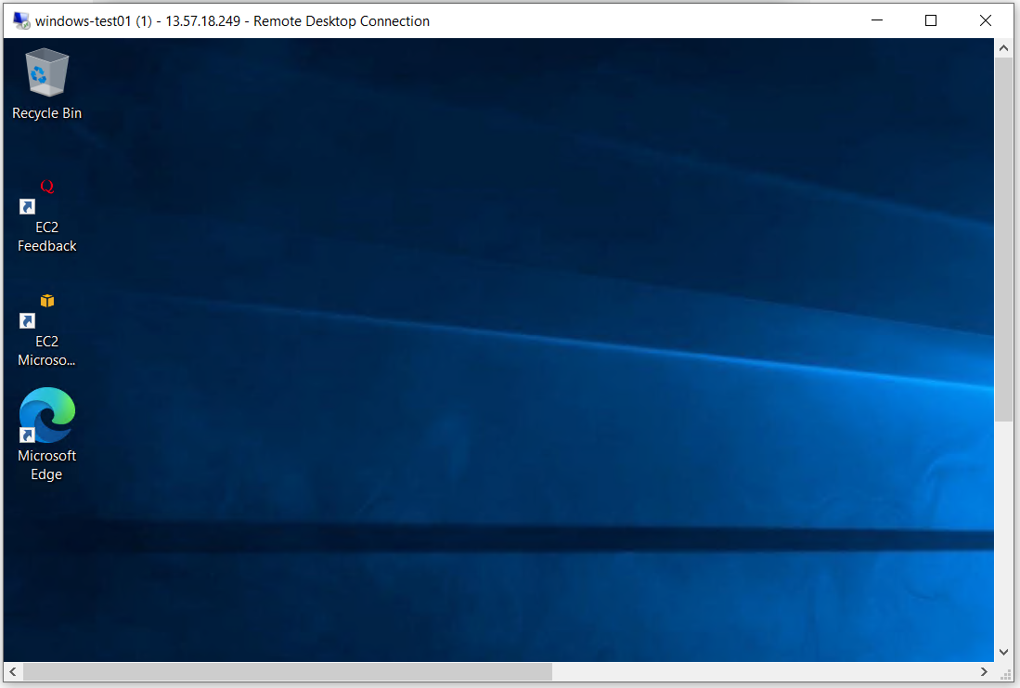

## Step12: open **CMD**, type “**systeminfo**” and press **enter** to view the system information about windows VM.

